Suggested file format and resolution for charts from Stata:

Export as a .PNG file

Ensure width of the png file is at least 4000 which should give the image enough resolution to be sharp in a normal journal size.

Example:
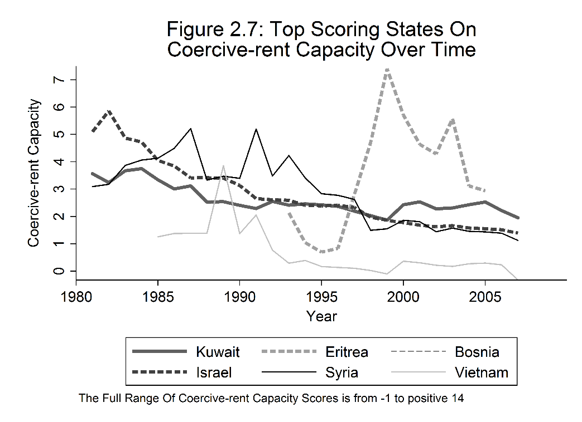

After the chart code in Stata 13 or later type:

graph save graphtitle.gph, replace

graph export graphtitle.png, width(4000) replace

This code should drop files directly into your working Stata file on your hard drive. Please embed them in manuscripts as image files or send them separately.

Suggested chart style from Stata:

Please format charts for black and white printing. Charts look best in black and white when you minimize gray in the background. If you have multiple lines in charts please be sure they have symbolic as well as color differences (for example dots and dashes rather than just red and blue) because it makes them easier for readers to understand in black and white.

We recommend ensuring your charts have a purely white background in graph or plot region with mostly black lines and text.

Before entering in the code that produces your graphs you can set a color and style scheme, we prefer schemes like "lean1" or "s1mono" in Stata 13 or later.

Example:

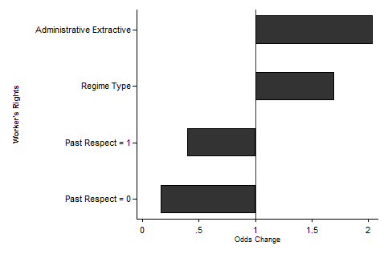

before the chart or plot code is entered type:

set scheme "lean1" or set scheme "s1mono"

to ensure a white background include commands: plotregion(style(none)) or graphregion(color(white)) bgcolor(white) color(black)

Consult Stata guidebook for additional commands and formatting to make graphs and charts as clean as possible.

